Monday 20th April 2020 XX.IV.MMXX

Wider curriculum
Every day, I will send a lesson or two that focusses on the wider curriculum that we teach at school (RE, PE, PSHE, Geography, History, Art, DT, Science, Computing, Music, French). I will try and keep this the same as our school timetable to help you maintain a clear routine. You will have one PE lesson a week that requires you to look at famous athletes, from past and present. But please make sure that you are staying active. Remember, the Joe Wicks workout on youtube is also a great start to the day.
On Mondays, we will focus on PE and RE.
PE
Your task for today is to research 1 famous sporting icon from the list below. You may select any of the legends from the list and you can display your findings in any way you like (poster, leaflet, biography, fact file, PowerPoint or anything else you can think of).
Michael Phelps, Sir Mo Farah, Serena Williams, Dame Jessica Ennis-Hill, Lennox Lewis, Sir Chris Hoy, Sir Bobby Charlton or Michael Schumacher.
I have purposely not chosen any footballers this week as I think we have a good knowledge of these already! It would be great if we can keep these and make a huge sporting profile of famous sporting figures that have changed sport forever.

RE
Please see the instructions for RE below.
That’s it for today! Please post complete work on the Heron Class padlet (https://padlet.com/MrJonesHeronClass/blspozhn28gi)or email to Heron@st-whites.gloucs.sch.uk

RE Week 1 UKS2: Creation or Science: WALT: Understand the creation story from Genesis from the Bible.
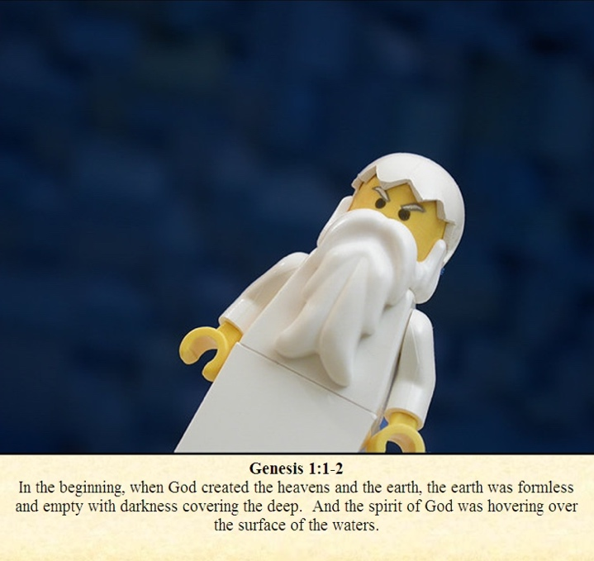
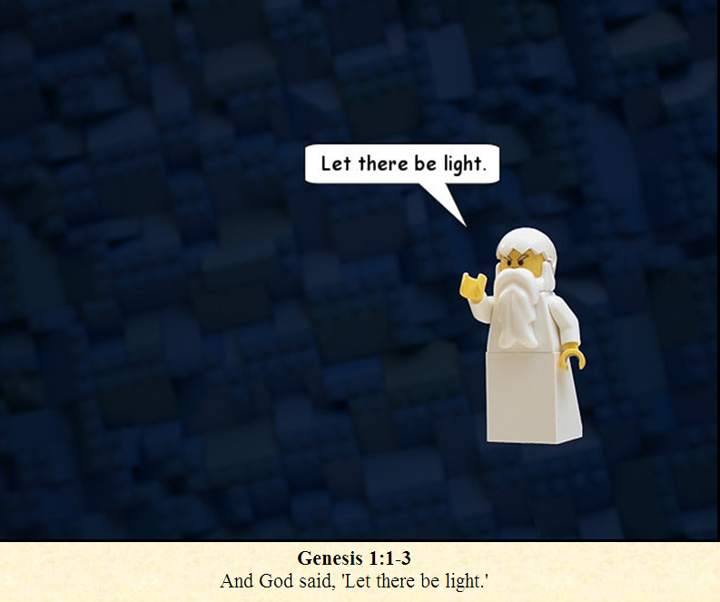
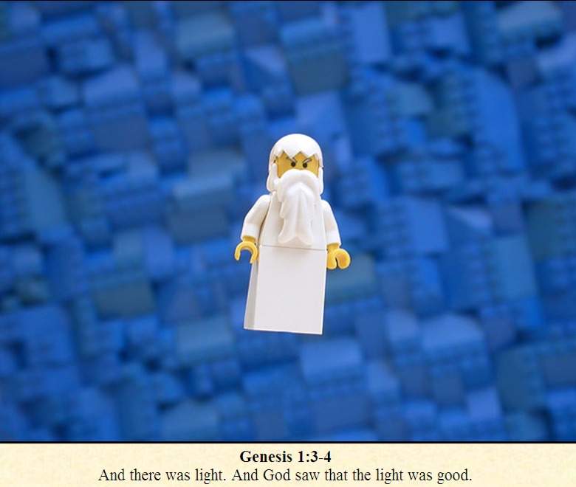
Please read the story from Genesis below in Lego cartoon.

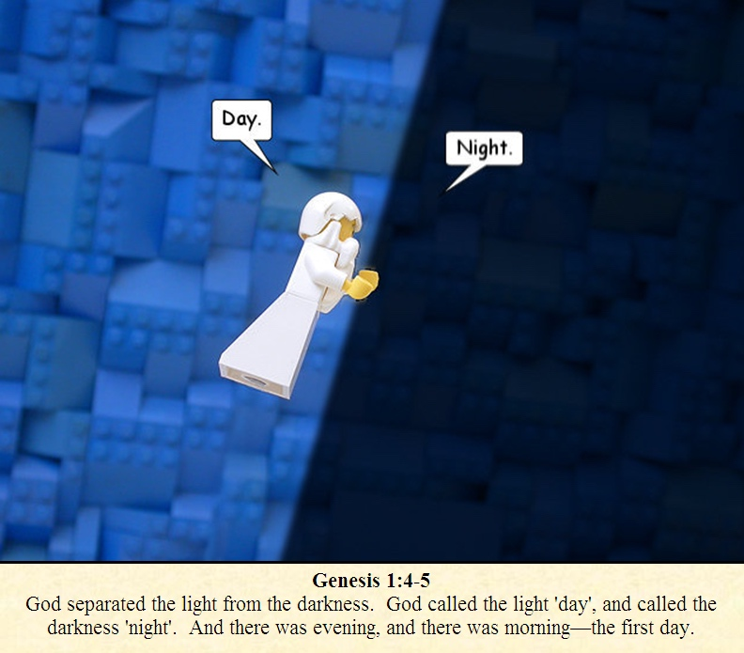
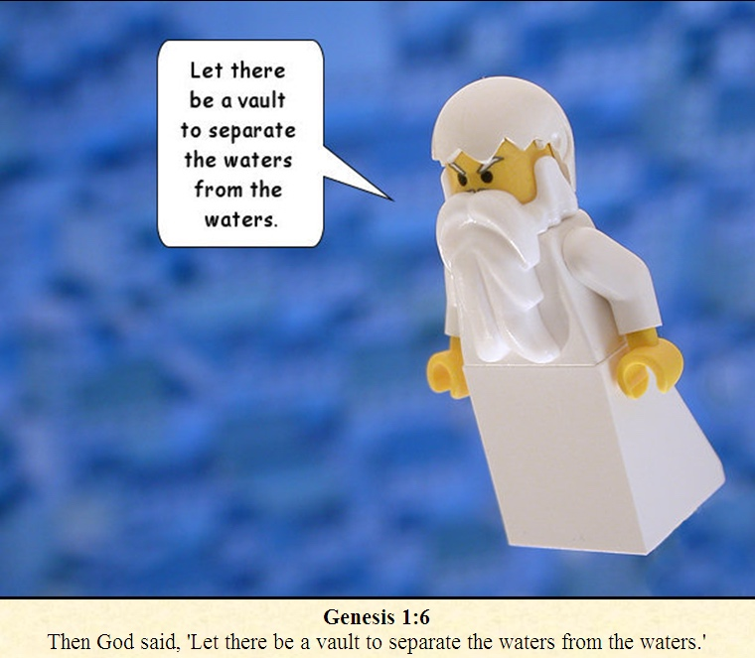
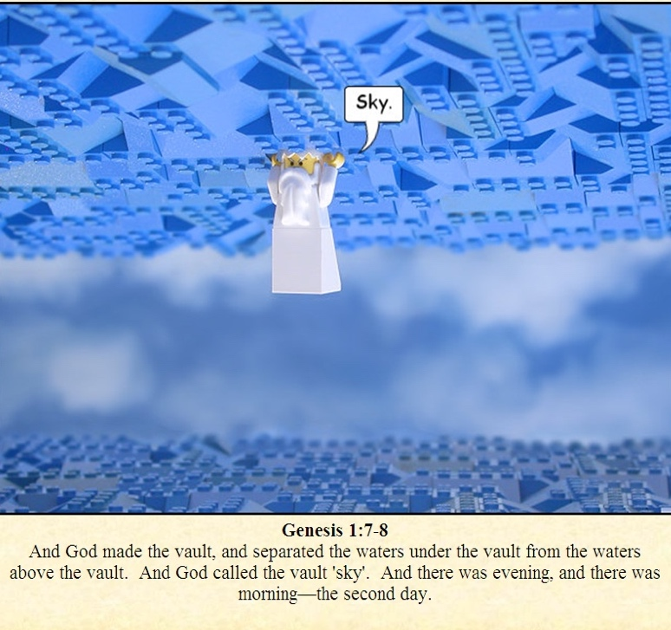

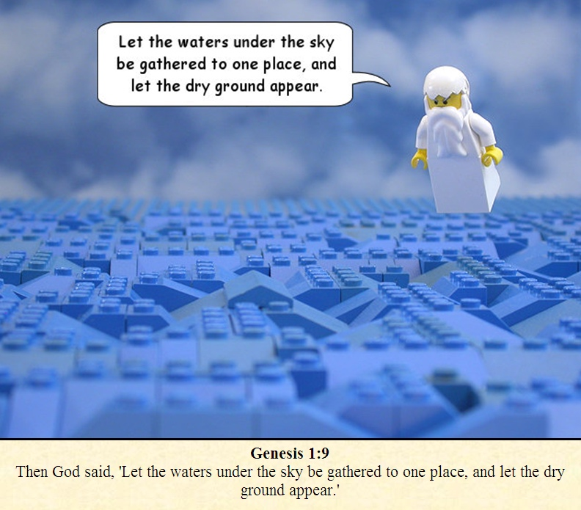
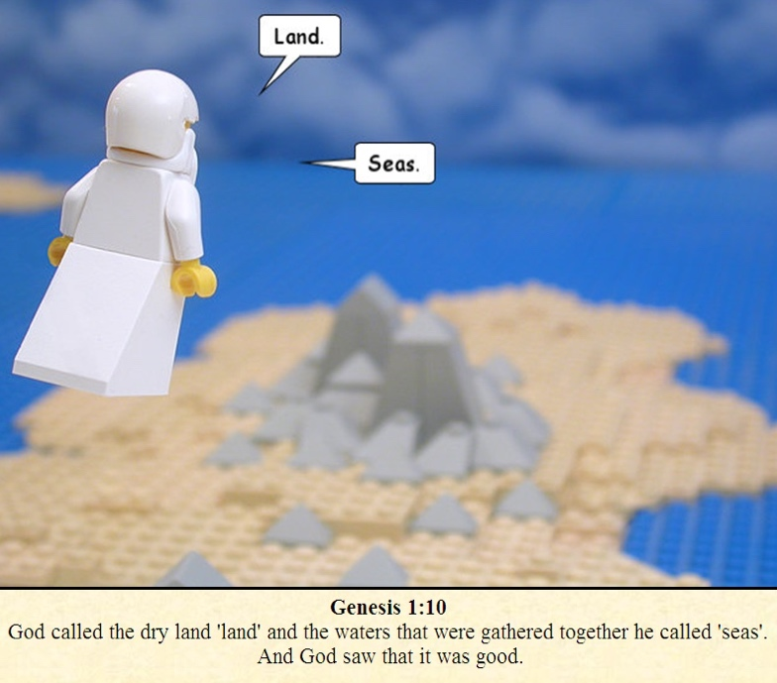
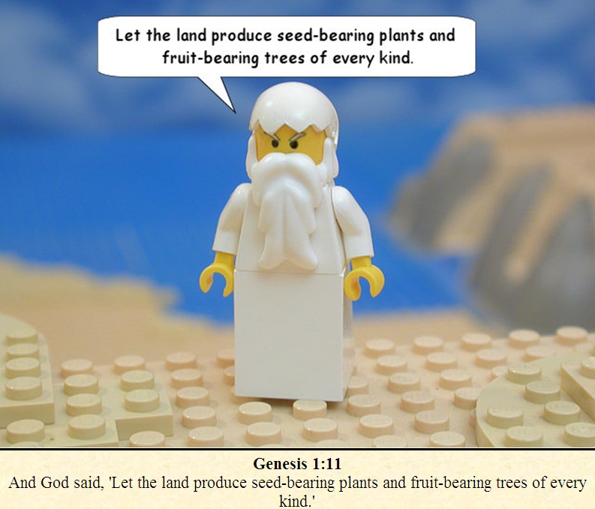

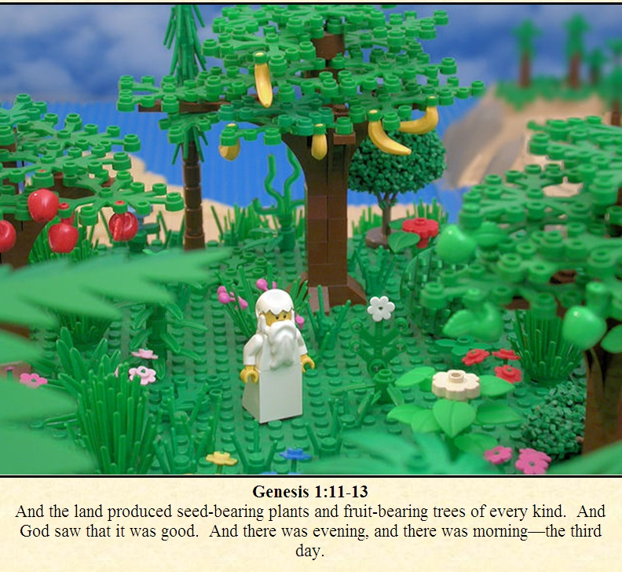
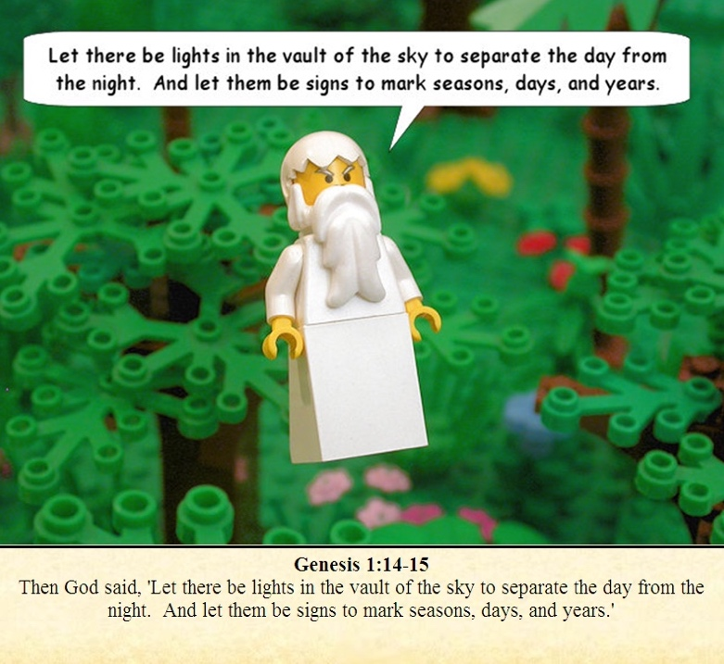
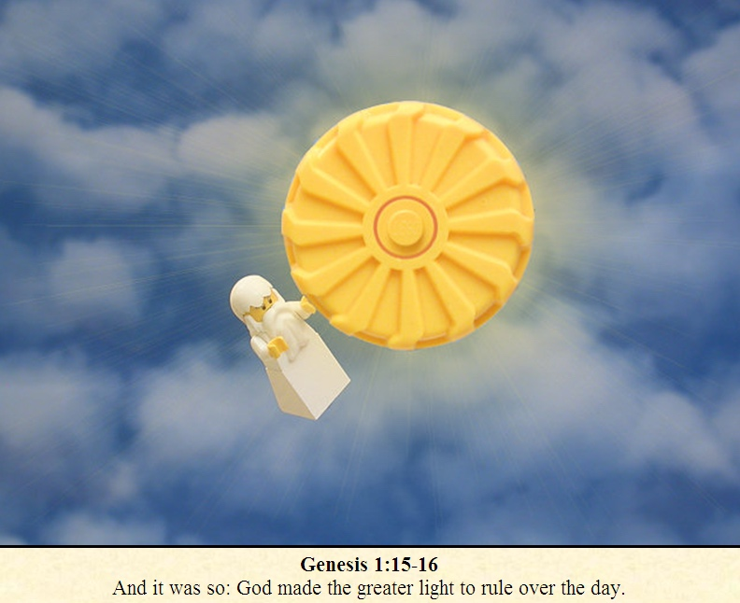

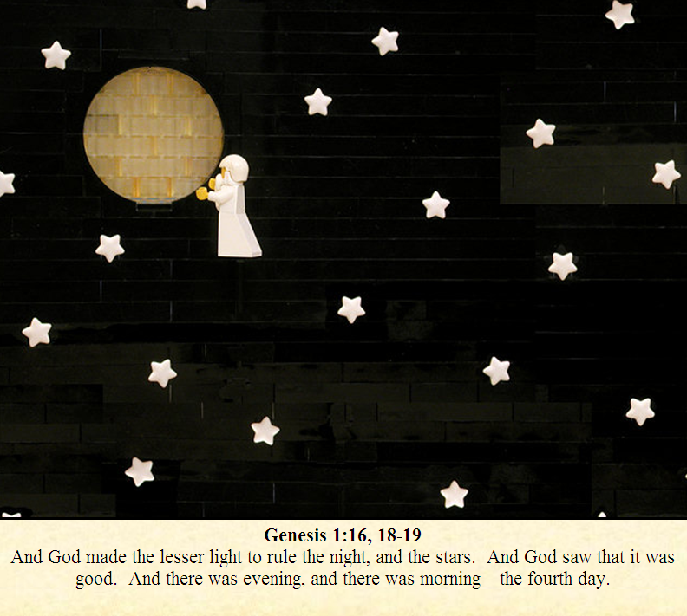
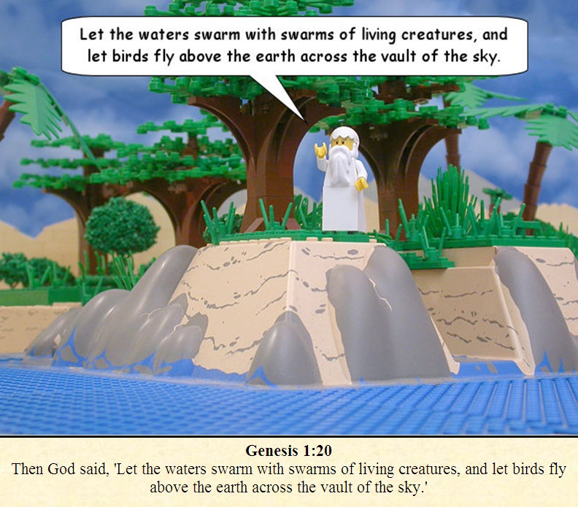
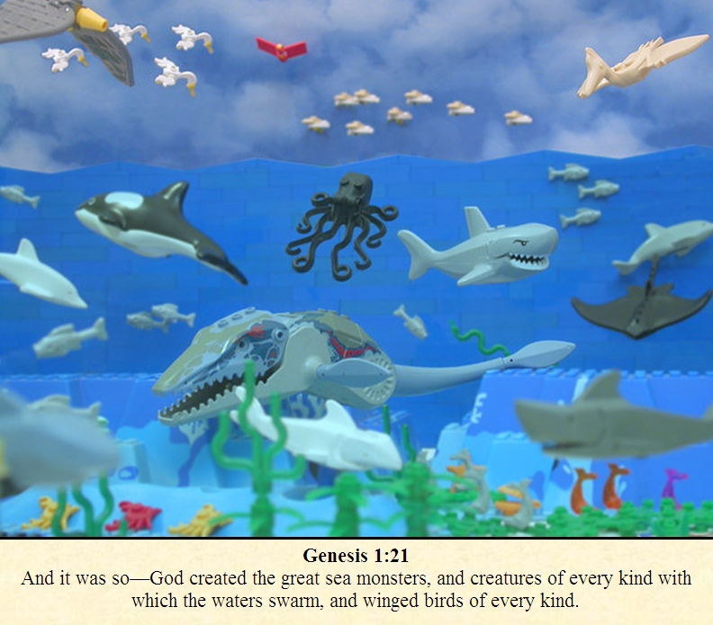

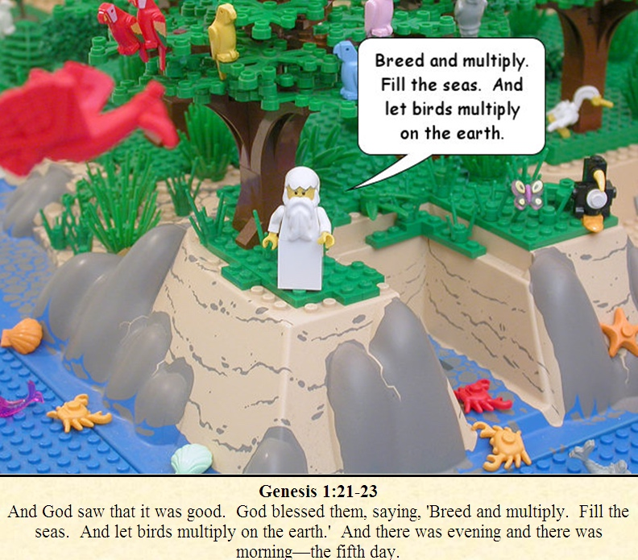
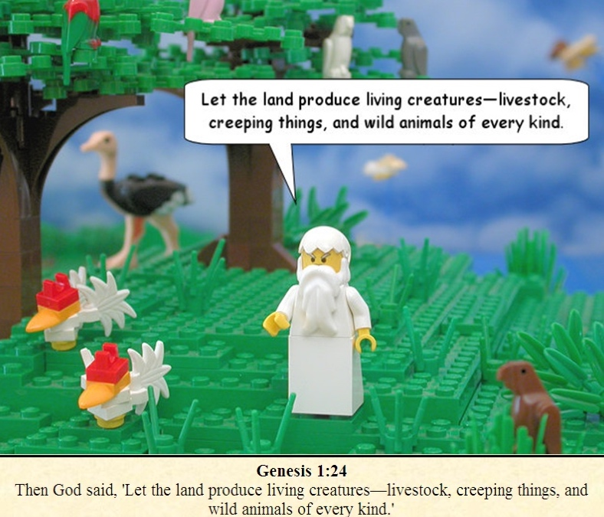
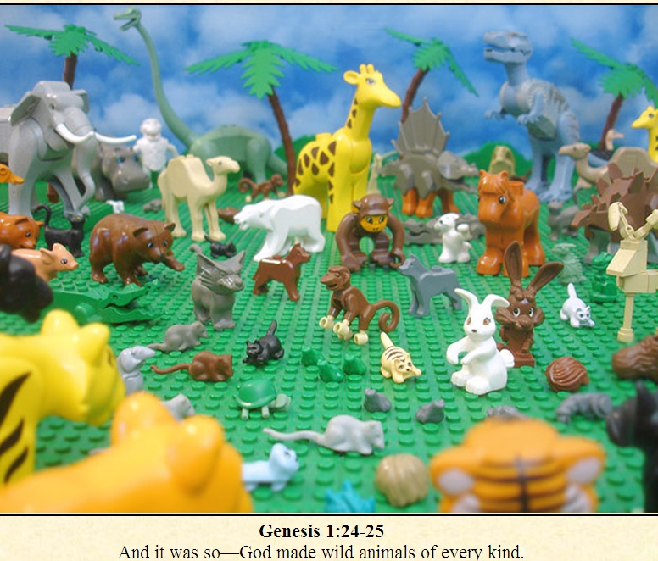

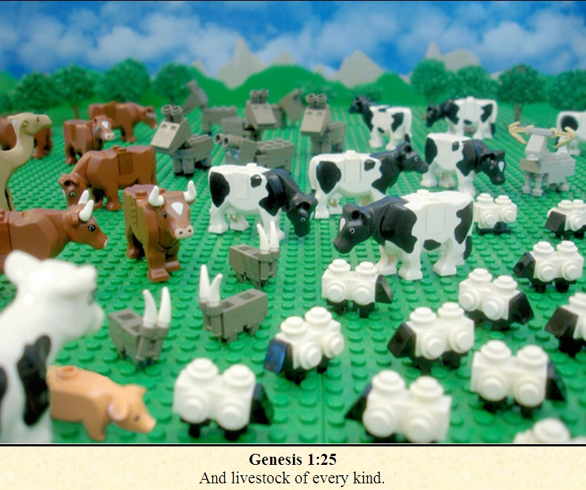
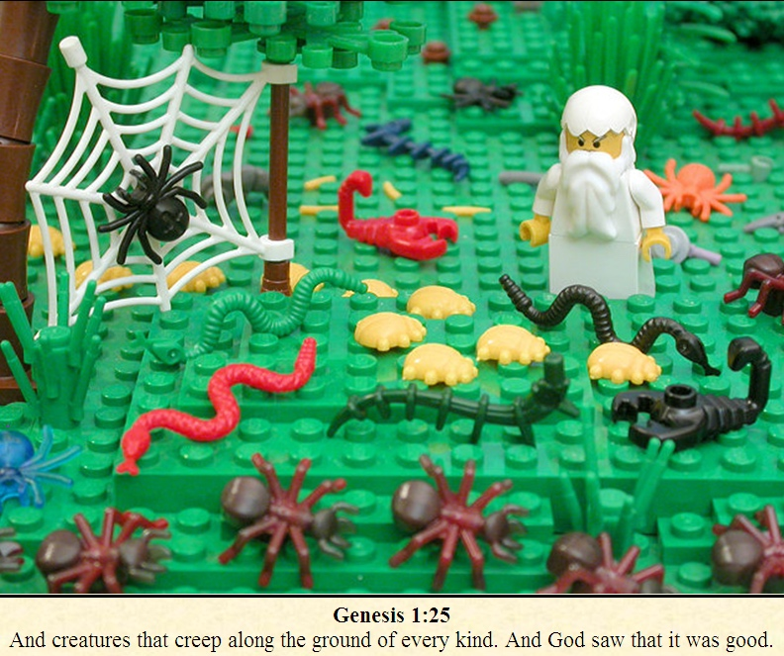
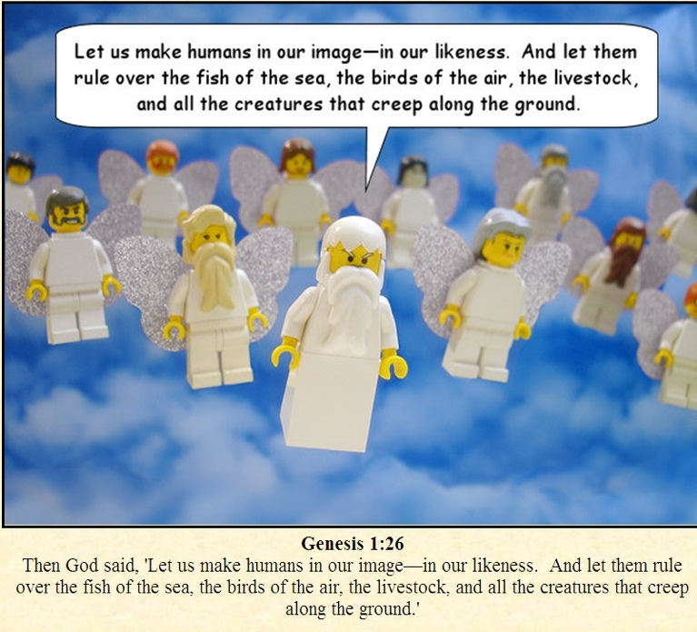

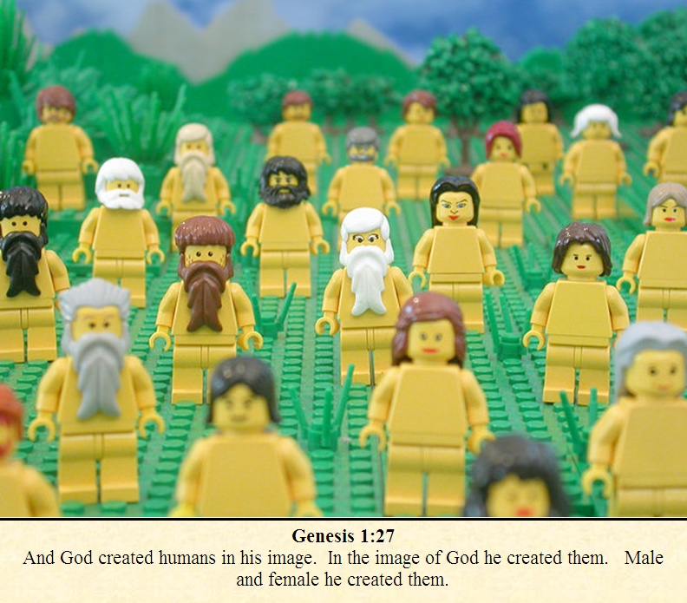
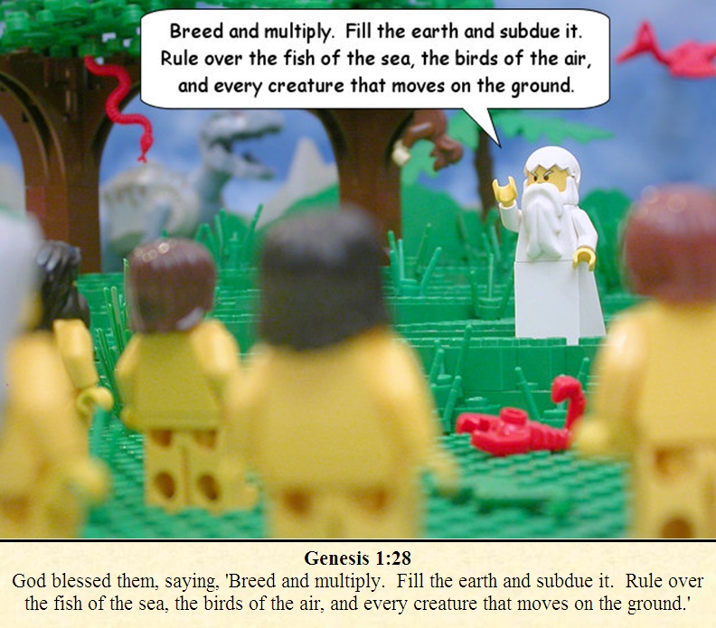
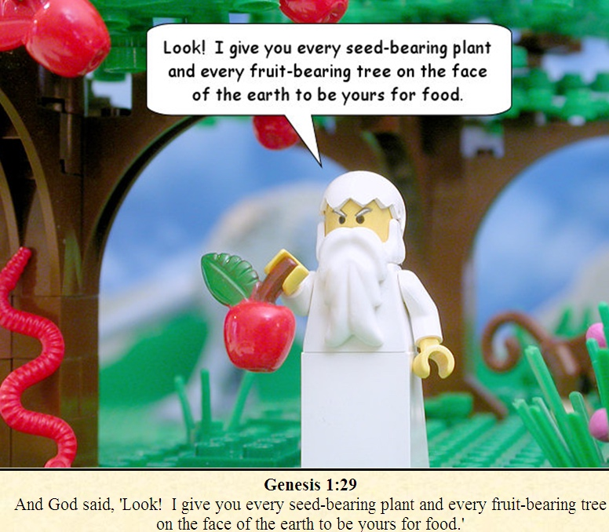

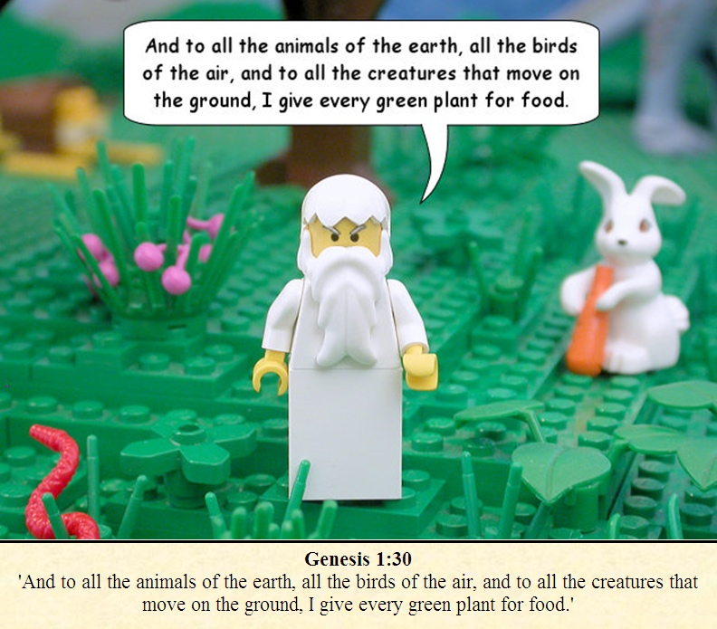
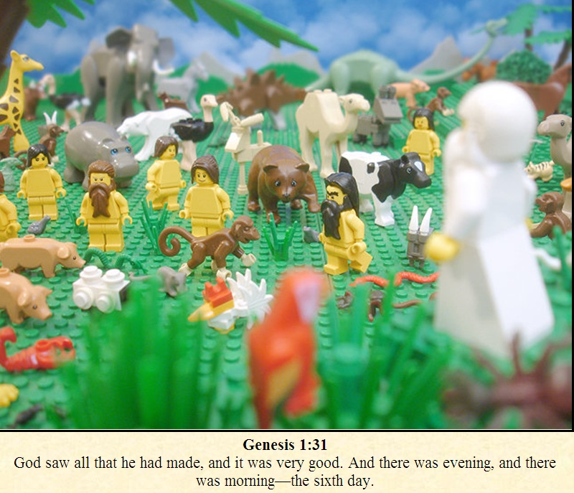
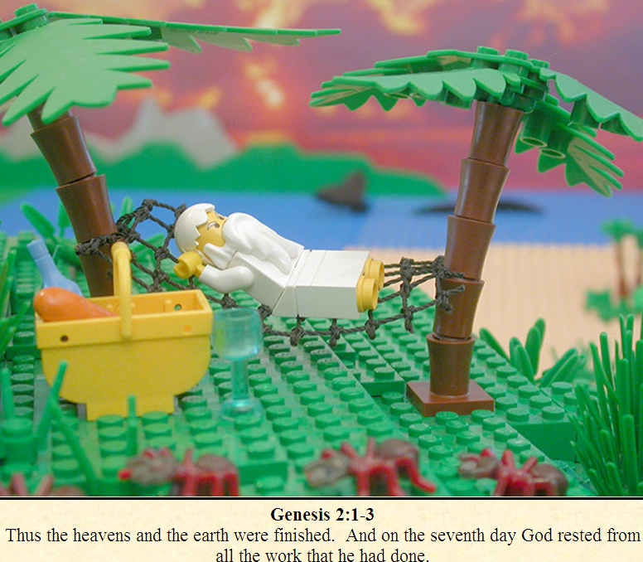

Now, please answer the question below on the story of Genesis.

- What is the story about?
- What did God create first?
- How does this story make you feel?
- What parts did you find interesting?
- What questions does this story make you want to ask?

Optional activities.

- Create your own comic strip for the story of Genesis.
- Create your own scene out of Lego from home.

