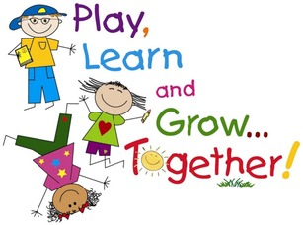
Our goal here at St White’s is to plan topics that reflect the views and interests of our children. We do this by: providing a starting point for discovery and investigation; introducing ideas that will stimulate and excite; incorporating challenge and a desire to learn and are flexible.
Our Long Term Planning in EYFS is informed by a range of different documentation that includes:
- Statutory framework for the Early Years Foundation Stage (DfE)
- Early Years Foundation Stage Handbook (DfE)
Personal, Social and Emotional Development  - Building confidence to choose activities and discuss ideas  - Build awareness of needing help, and confidence to ask  - Confidence to speak in a group of familiar peers  - Working as part of a group, following rules where appropriate  - Forming positive relationships with peers and adults  - Playing co-operatively, taking turns  - Develop a positive sense of self  - Respect others and the environment | English  - Use phonics to decode simple words  - Read a selection of common exception words  - Read simple sentences and discuss what has been read  - Use phonics skills to write simple words and sentences
Mathematics
- Count reliably with numbers up to 20
- Use counting on and number knowledge for simple addition and subtraction
- Begin to recognise and describe simple patterns
- Use everyday language to talk about size, position, time etc
- Use mathematical language to describe shapes and objects
Communication and Language  - Listening attentively, including while comleting tasks  - Listening to stories and responding to prompts and ideas  - Follwing instructions when carrying out activities  - Express ideas, includinh real life and fictional ideas  - Using past, present and future forms of language | Understanding the World  - Talk about events in their own lives and that of their family  - Know similarities and differences between communities  - Talk about similarities and differences between plants, animals and objects  - Recognise that technology is used in homes and schools
Physical Development  - Developing control and coordination of movement  - Handling equipment and tools including a pencil  - Learning about healthy diet and exercise  - Managing their own hygiene and personal needs | Expressive Arts and Design  - Experiment with songs, music and dance  - Use a range of artistic materials, tools and techniques  - Work imaginatively to create new works  - Represent ideas through art, music, role-play, dance and stories
- Development Matters in the EYFS - A Unique Child - full document. (DfE)

