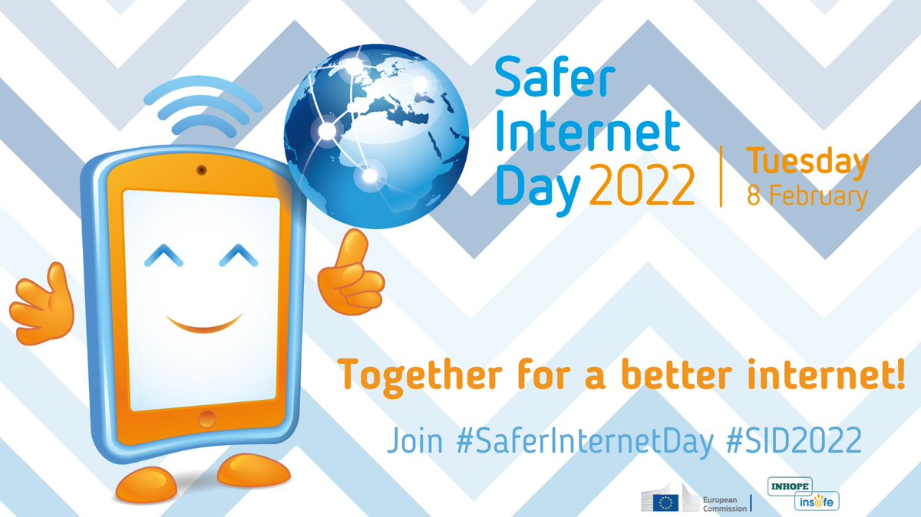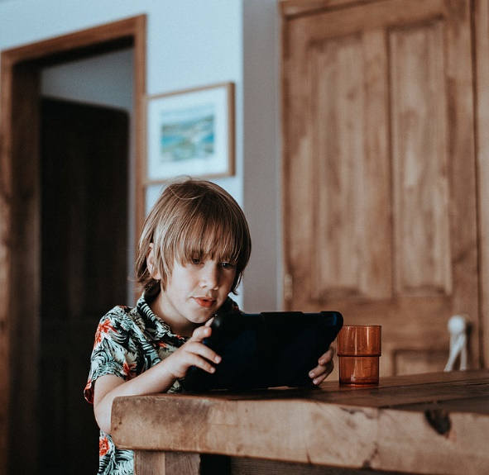

Top tips for keeping children safe when using the internet

* Establish a family agreement to manage your familie’s time online
* A reward system can be a great way of earning online time, so that its earnt rather than a expected.
* Look at the controls available on devices and on your home Wifi. Parental controls are also helpful but it is equally important to have a conversation with your child to set expectations and boundaries.
* Be aware of what your child is doing online and keep the door open so that you can hear.
* Talk to your child about what they should do if something goes wrong whilst online.
* Make sure the games that your child is playing are age apropriate, if it is not it may affect their mental health and well being.

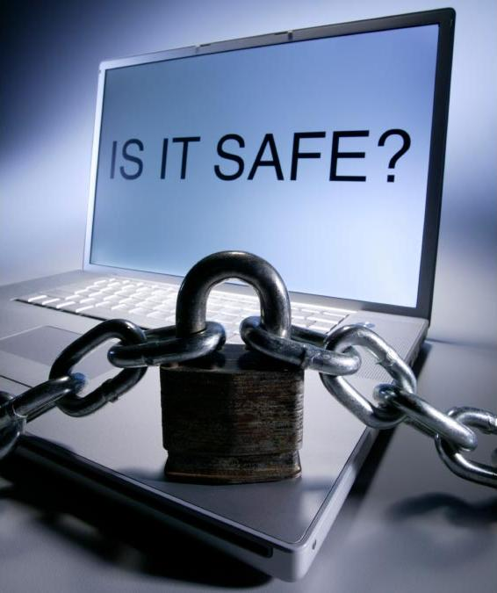

For further information and support, please visit https://saferinternet.org.uk/guide-and-resource/parents-and-carers