Monday 20th April 2020 XX.IV.MMXX
Maths
Over the next few weeks, we will aim to complete the year 5 maths curriculum. This means that there will be some new learning. We are doing to follow ‘White Rose Maths – Home Learning’. This means that there will be a video to start off each day as well as a worksheet and answers. I will be on hand if you want any further assistance so please just get in touch.
https://whiterosemaths.com/homelearning/year-5/
Week 1 – Lesson 1 – Decimals up to 2 dp (decimal place)
Watch the video first and then have a go at the worksheet. Don’t worry if you can’t print it out: you can complete it on paper like we would in maths.
Check your answers using the link on the website.
If you get stuck, please post on padlet or email and I will do my best to help you.
Reading
You will be set a reading activity every day which is similar to what we would do in Guided Reading. Please find time to read at other times during your day just for the fun of it!
This week guided reading is focussed on making predictions using evidence from the front cover and the blurb. I am going to introduce you to some great children’s novels which you may like to read. Remember a 3-mark question requires you to make at least 2 points with evidence and explain your thinking.

Spelling
When we want to change words from ‘-ent’ to ‘-ence’ we remove the t and add ‘-ce’. Complete the machines words to see the words that have come out.
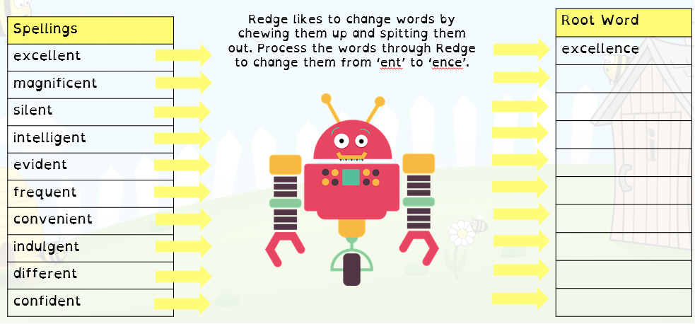
I will send you the answers tomorrow!

Spelling
Your task is to sort the words below into two groups. The words that have a ‘tious’ (making the shus sound) and ‘ious’ (making the eeus sound). I would then like you to find the definitions for 3 of the words, it is important to understand what they mean in order to spell them.
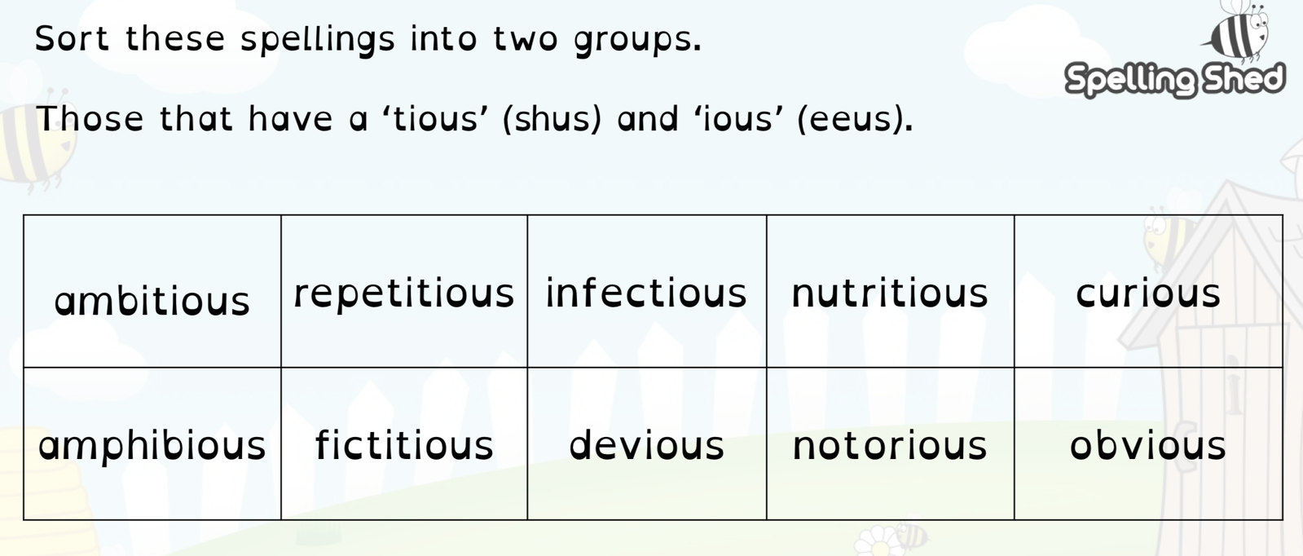

I will share the answers with you tomorrow.
English
This term we are going to focus on writing for a purpose and thinking about your audience. Every Monday, I am going to set you a letter writing challenge. Letters are really important as they are what lots of grown-ups use to try to get what they want! Please feel free to adapt the purpose slightly if you can think of a better one that will result in your letter being sent to a real person! Remember to do a quick plan about what you want to put in each paragraph before you start.
Week 1 – You have worked very hard with maths, reading and spelling so far this morning. Write a persuasive letter to your parents to convince them that you should be allowed to have an extra chocolate biscuit (*or other treat) with your lunch. You will be able to judge the success of the letter by if it works!
Remember that spelling, grammar and handwriting will be important if you want your family to read and understand the letter.

Unfortunately, due to the file size I was unable to put the afternoon activities for today on the bottom of here. Please see the other attached file named, Monday 20th April afternoon. This should all be back on one document tomorrow!

